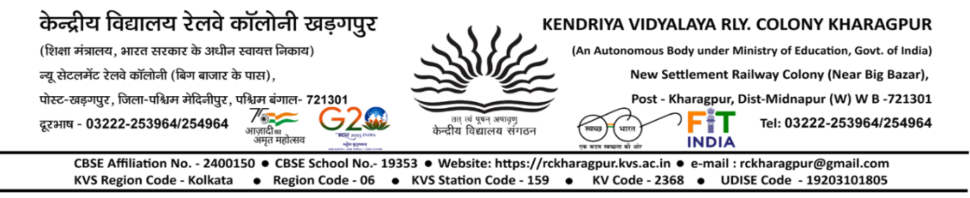

Notice

School will remain closed for WINTER BREAK from 25th Dec 2023 to 14^{h} Jan 2024(Sunday)
Vidyalaya office will remain open on all working days.

Principal
Shri. Sudip Mandal

